**Faculty Research Design Document**

**Database Connectivity & Access**

**Milestone 1**

Lowell Pence, [lxp3901@rit.edu](mailto:lxp3901@rit.edu)

Campbell Schweickhardt, [rcs5166@rit.edu](mailto:rcs5166@rit.edu)

Vincent Cheng, [vkc9448@rit.edu](mailto:vkc9448@rit.edu)

Assignment Table =* A table that provides abstracts information using text field that contains the information for research assignments, projects, or interest.

Search_Key =* A table that contains the keywords to locate the abstracts information for a specific research assignments or projects.

Researcher =* A table that includes the research assignment that the facility was involved with.

Faculty =* A table use for authentication, requires the faculty id and password to update, insert, or delete any abstracts information to the assignment table.

Student =* A table for authentication, login is optional which requires the student id and password to update or insert any abstracts information to the assignment table.

External People =* A public user that does not require any authentication to access the assignment.

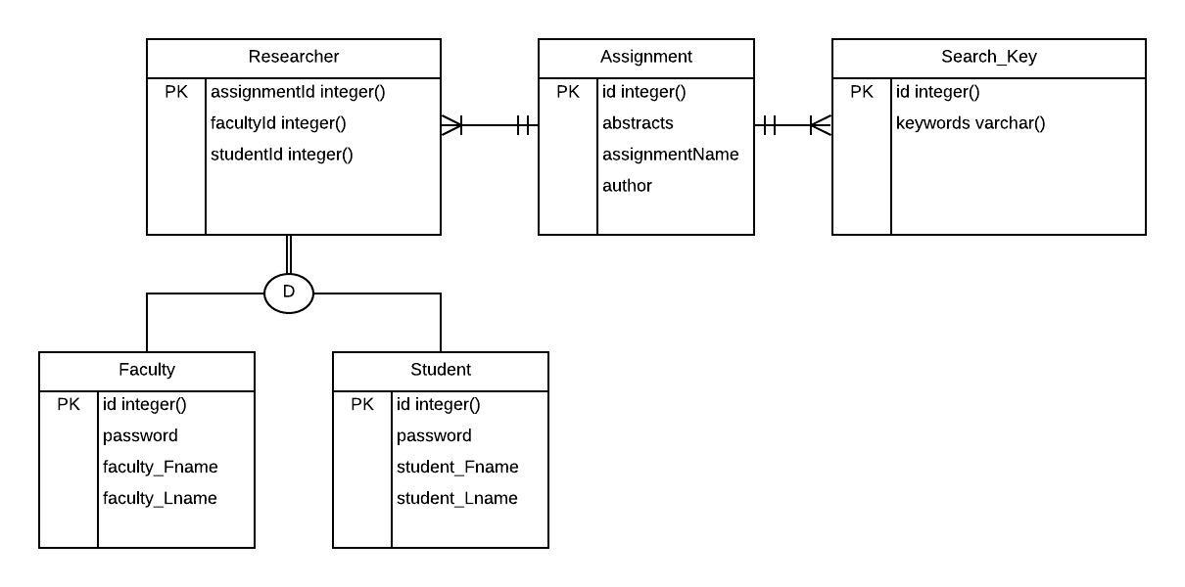

<https://www.lucidchart.com/invitations/accept/7daf8cad-6f67-4634-af4d-164390af71f2>